### Miniature House #10 - A Cape Cod with a Shed Dormer and a Porch

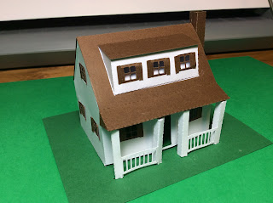

I just learned that the name of the dormer that I made for this house is called a shed dormer. You learn something new every day!  
  
I used card stock. I do recommend using a glue dot to make the porch. Insert the tab and use a glue dot to adhere to the paper. I am very impatient with the drying time of glue and glue dots work wonders.

